**Informatica – Mapping Screenshots**

**Simple Mapping:**

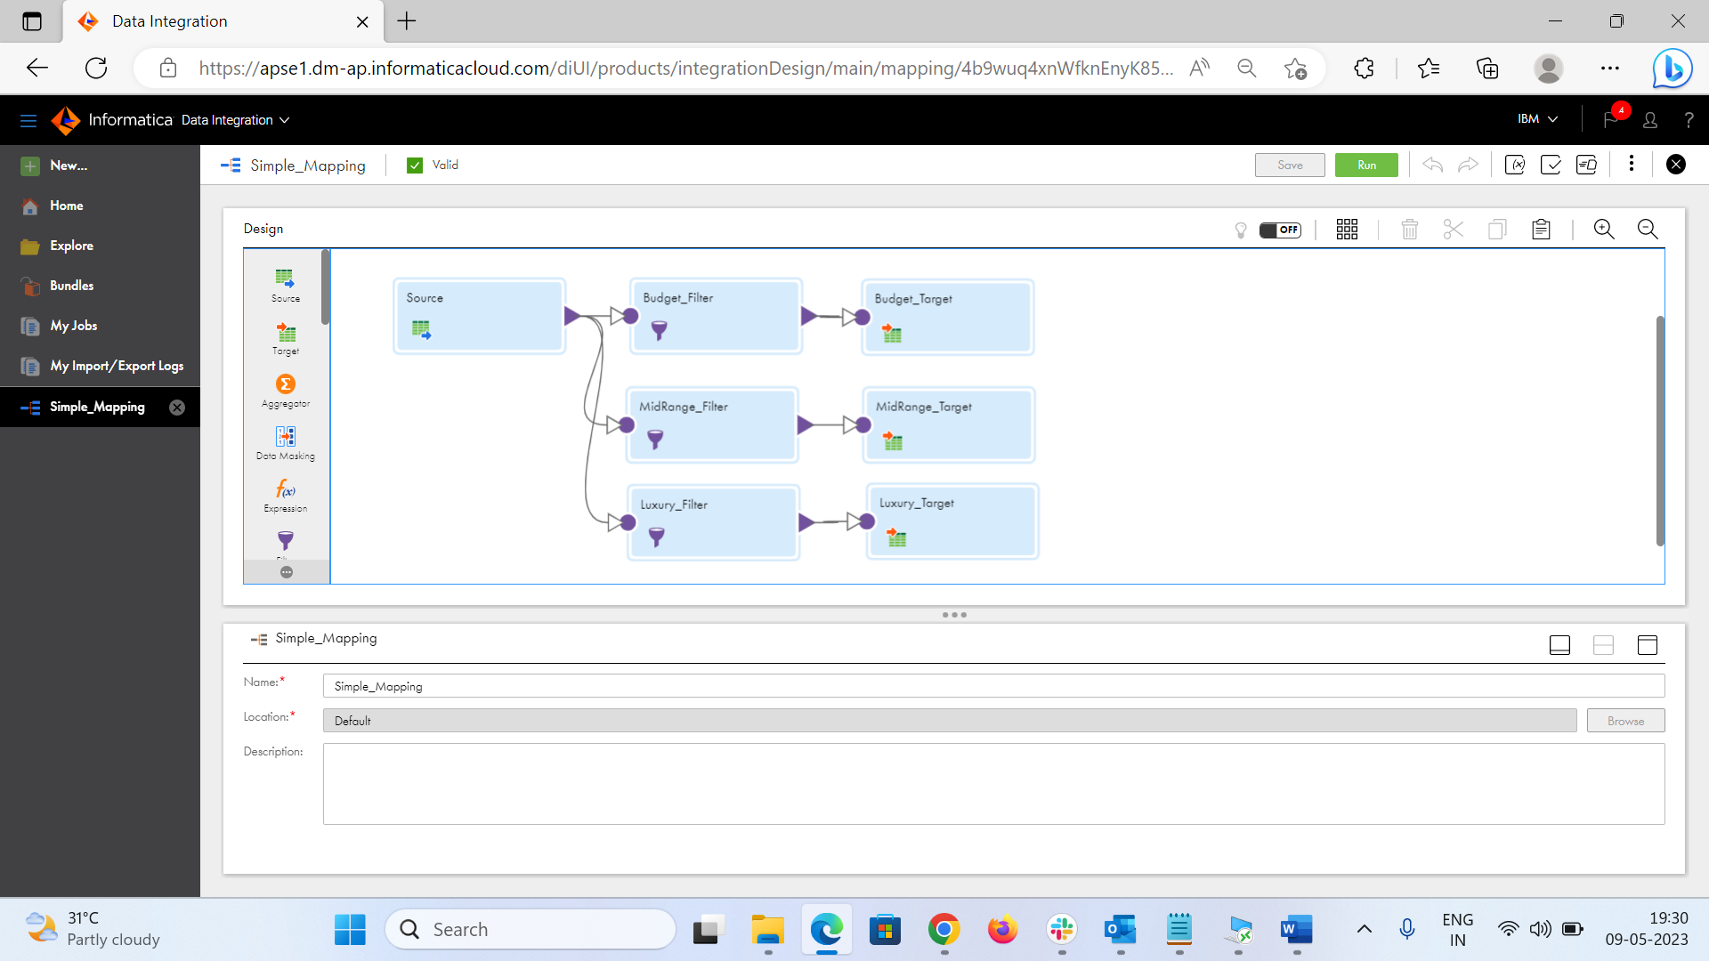

**Complex Mapping:**

**Lookup Mapping:**

